**Jezarelle T. Lanzaderas**

Cagayan de Oro, Misamis Oriental 9000

Contact Number: +63975-625-965

Email: [lanzaderas.jezarelle@gmial.com](mailto:lanzaderas.jezarelle@gmial.com)

March 19, 2021

**Arch. Andy Cohen**

Chief Executive Officer

Gensler Company

California, U.S.

Dear Sir,

Good Day!

I recently came across an advertisement for a vacancy at Gensler Company for the position of commercial architect. This information on your website has enlightened me, and I would like to apply for it.

I want to work as a commercial architect for your company and show that I can be a valuable asset while also growing personally. In this letter, I've outlined my professional background and qualifications.

In 2027, I graduated with a bachelor's degree in architecture from the University of Science and Technology of the Philippines. Following my graduation, AIDEA Philippines, Inc. offered me an internship. I spent a year there, succeeding in every decision I made on behalf of the company. Following that, I gained a great deal of experience in commercial architecture and am now able to integrate a distinct style and design into my work. Following my internship, I worked for five years as an assistant commercial architect at Visionary Architecture Inc.

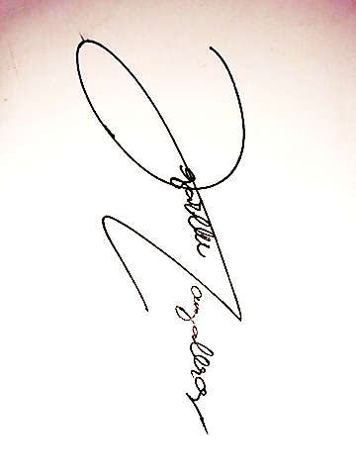In a face-to-face interview, I'd like to talk about how I can bring value to Gensler Company and answer any questions you might have about me and my portfolio.

Sincerely,

Jezarelle T. Lanzaderas